How would I find colitions between the player and Breakages?

why is my terminal returning none.

Why am I getting no attribute error

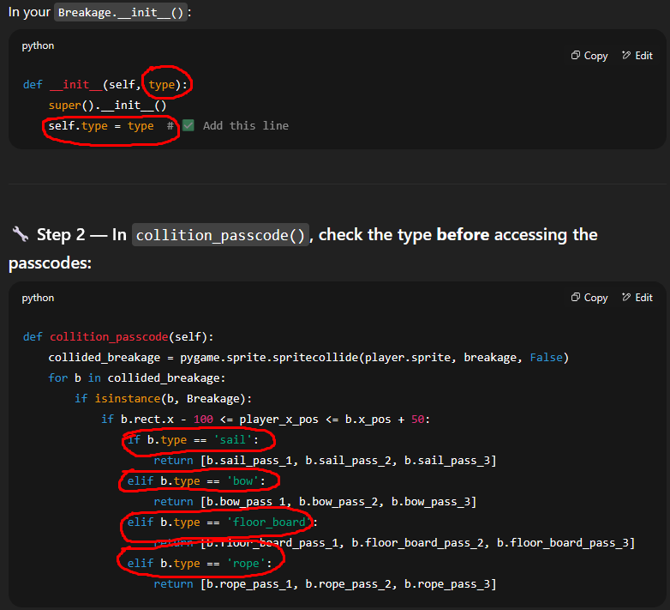

The b’s were origenly self and ai also told me to change them

Code with ai 

